**Data Visualization Project Proposal**

* **Basic Info.**
* Project Title : Soccer Stats
* Names : Sravan Kumar Neerati, Sreekanth Reddy Konda
* Emails : [u0931101@utah.edu](mailto:u0931101@utah.edu) , [u1140489@utah.edu](mailto:u1140489@utah.edu)
* UID : 0931101 , u1140489
* Project Repository Link : <https://github.com/Meerkat3/SoccerStats>

**Overview:** Soccer stats is a data visualization designed to see various details of top 50 soccer players and teams in various clubs. This includes two visualizations.

1. Showing various attributes of the player, how is his performance over the years, comparison of players performance based on different attributes.
2. Showing a team’s performance in a club over the years and the points scored by each club in each season.

**Background and Motivation:**  Though there are many visualizations online which shows these data, we couldn’t find a place where we can compare multiple players based on their score in various areas like dribbling, free kick accuracy etc.

We are trying to answer the above questions. Our visualization is different in showing as many as 20 attributes in various areas to see a player’s performance. Also we are trying to provide a comparison tool to compare two or more player’s performance based on different attributes.

**Project Objectives:** We aim to show the highly sought after mainstream Soccer stats in overview and details of the Player attributes and their performance over time, Insights of a club’s performance and how the betting fared on the matches(tentative).

Main questions we are trying to answer:

1. What are the basic details and latest scores of a player in different areas like penalties, marking, dribbling etc.
2. How well is a player improving in various areas over the years?
3. Comparing two or more player’s performance over the years?
4. Points scored by a club in a league per season?
5. Comparison of club’s performances in specific leagues over the years?

**Related Work and Inspiration:**

**Data:** The data is presented in SQLite format and we intend to do some pre-processing before storing them as csv/json for our final usage. If time permits we intend to have a backend server, serving the data.

* Link: https://www.kaggle.com/hugomathien/soccer/data

**Data Processing:** We initially thought there won’t be much processing needed as we have all the data in various tables in SQLite. But as we started writing python code to deduce the data we realized that we needed many joins among tables. Also there were multiple records corresponding to single year. We had to clean all this data and finally saved them in different csv’s which makes it easy to use them in our visualization.

**Design Evaluation and Implementation:**

We originally planned to show all the data belonging to top 50 players at once. But in feed back session we got a very good suggestion that helps in comparing players one by one. i.e we initially show that data of one player, then we can have the ability to include more players into that visualization. This will keep on adding multiple lines to the line chart to show the trend of all the selected players over the years. The following picture shows the trends of two players selected (current stage which doesn’t involve selection of players yet.)

We will have 2 tabs in the site. One for player specific visualizations and another for clubs related data visualizations.

**View 1: (Selection of player)**

We initially think about having a drop down to select the player. The following picture describes this

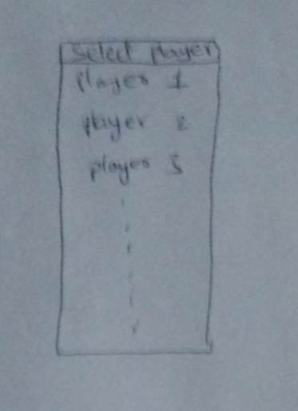

Then we came to know that it is difficult to select a player from drop down by scrolling in a small section. Then we decided to have a button which on click shows the names of all 50 players at one place, which makes it easy for the user to select.

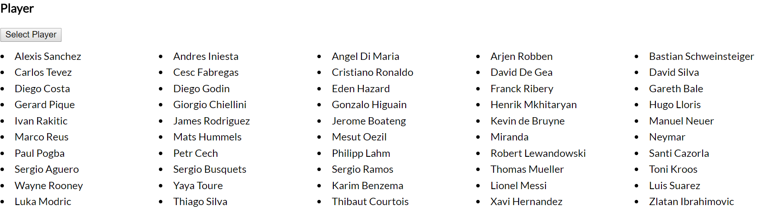

**View 2 (basic details of the player):**

We are decided to show the picture of the player upon selection, basic details and the details of the points (latest) he scored in various areas. We decided to go with the radar chart to show these attributes. This helps us in deciding in what areas the player is strong/weak. For example, we can clearly see that Lionel Messi is good in attacking attributes.

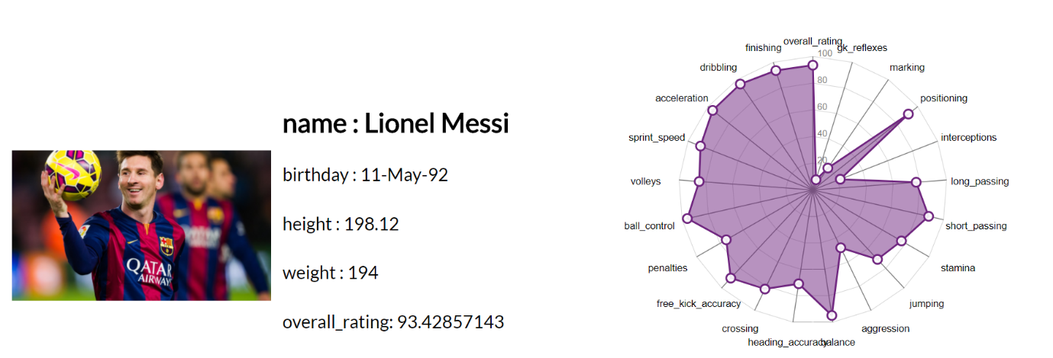

Like wise, we can see in what attributes a player is good at like attacking, defending, goal keeping etc.

**View 3:**

Initially we thought to have all the data corresponding to 50 players in a line chart to show how their performance was changing over the years. Then we thought to have an interaction, when the use hovers over the line, we will show the information of that particular player. Following picture helps to describe this.

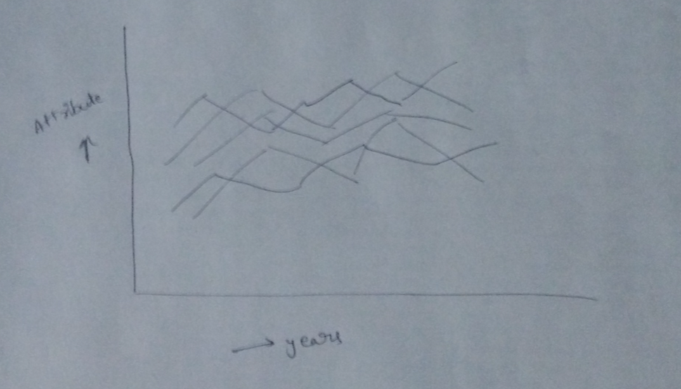

Then we changed it to initially have the data corresponding to a single selected player from view 1. Also the user will have the facility to add one more player to compare. For this, we are thinking to have a search box, when user types part of the player’s name, we show the suggestions. Once user clicks the player’s name, we will add one more line to the line chart. Colours are used to distinguish between players. Also we will have a tooltip to show player’s information on mouseover.

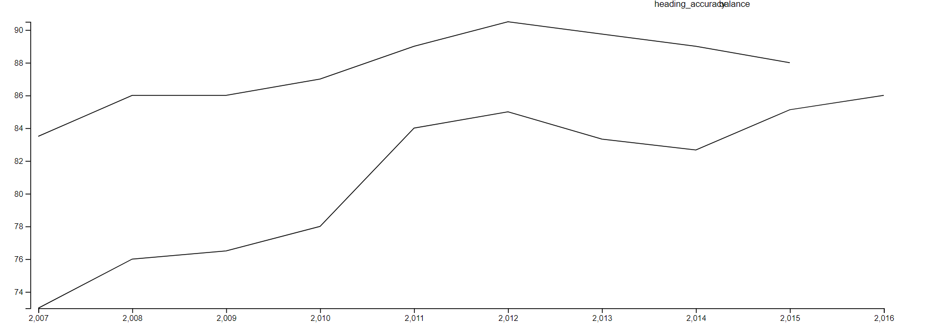

The above picture shows the trend of two players over the years. Along with this we will have a search bar on right side to include more players.

Initial interaction planned was to click on the year or place circles to click on the year to show details of the set of players selected in a bar chart that aligns with the y axis to highlight comparison of the players selected.

Addition of circles can lead to a bit of cluttering of the visualization. Hence we moved on to use a brush selection over the linecharts based on which we add new charts below the linecharts to highlight the comparison of players in those years.

View 4:

Based on the selection from the brush, We add respective barcharts for year the number of years.

The bars would correspond to the number of players selected for the line charts’ coparison.

The number of barcharts is dependent on the number of years brushed.

The following pictures show the implementation when the brush includes four years and two players.

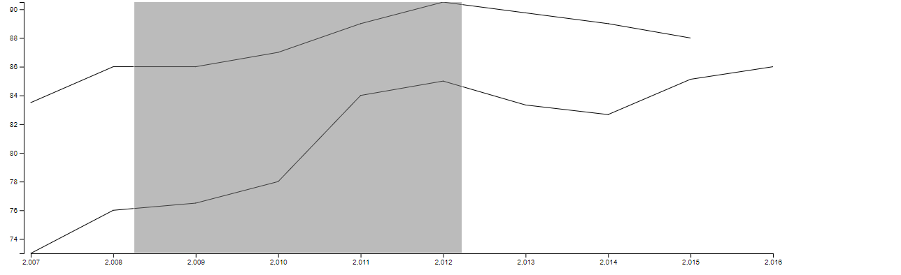

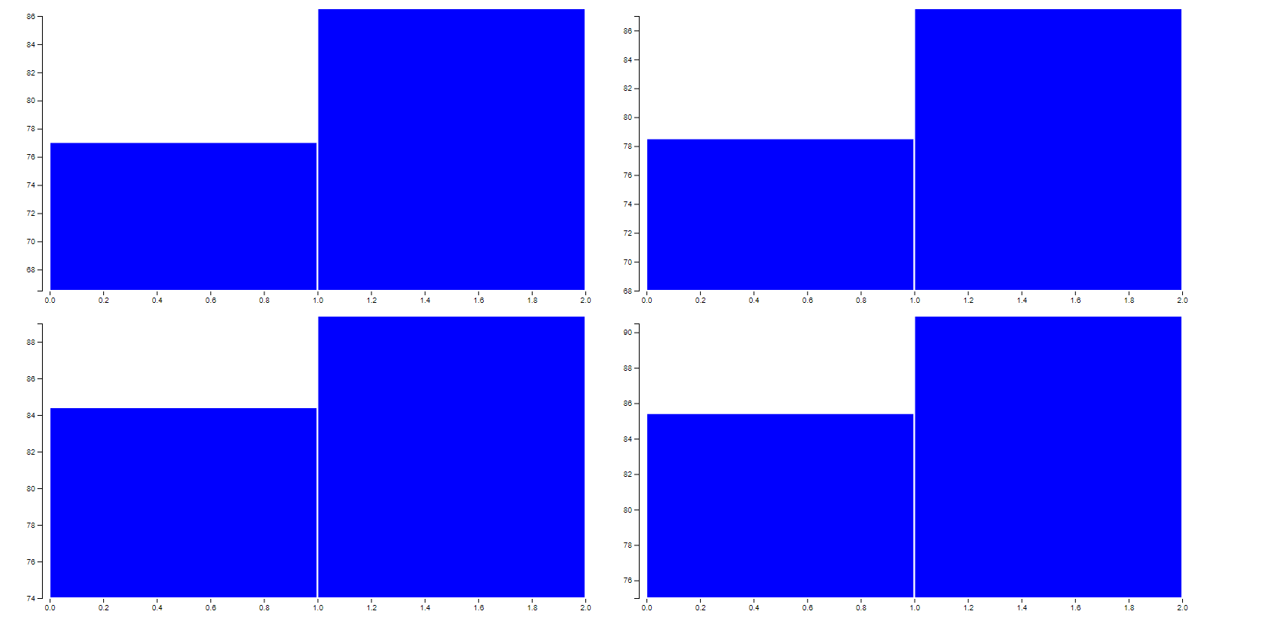

View 5:

We plan to show the heatmap of the clubs in a league in terms of the points scored over a set of seasons. The data spans over six seasons and there are a number of leagues at hand with good number of clubs in each of them.

The heatmap includes color coding for the number of points that the club scored in that season. This provides a good overview of the clubs perfomances and comparisons in a league at the same time.

View 6(tentative):

On click of the rectangle corresponding to a club over any of the seasons, we display a line chart of the clubs performance over the seasons. This is an enhancement over the color coding in the heatmap and provides a clear picture of the progress over years.

The user can click on the multiple rectangles and the linecharts corresponding to those clubs would be added to the linechart. The user can click again on the rectangle to remove that line from the line chart. 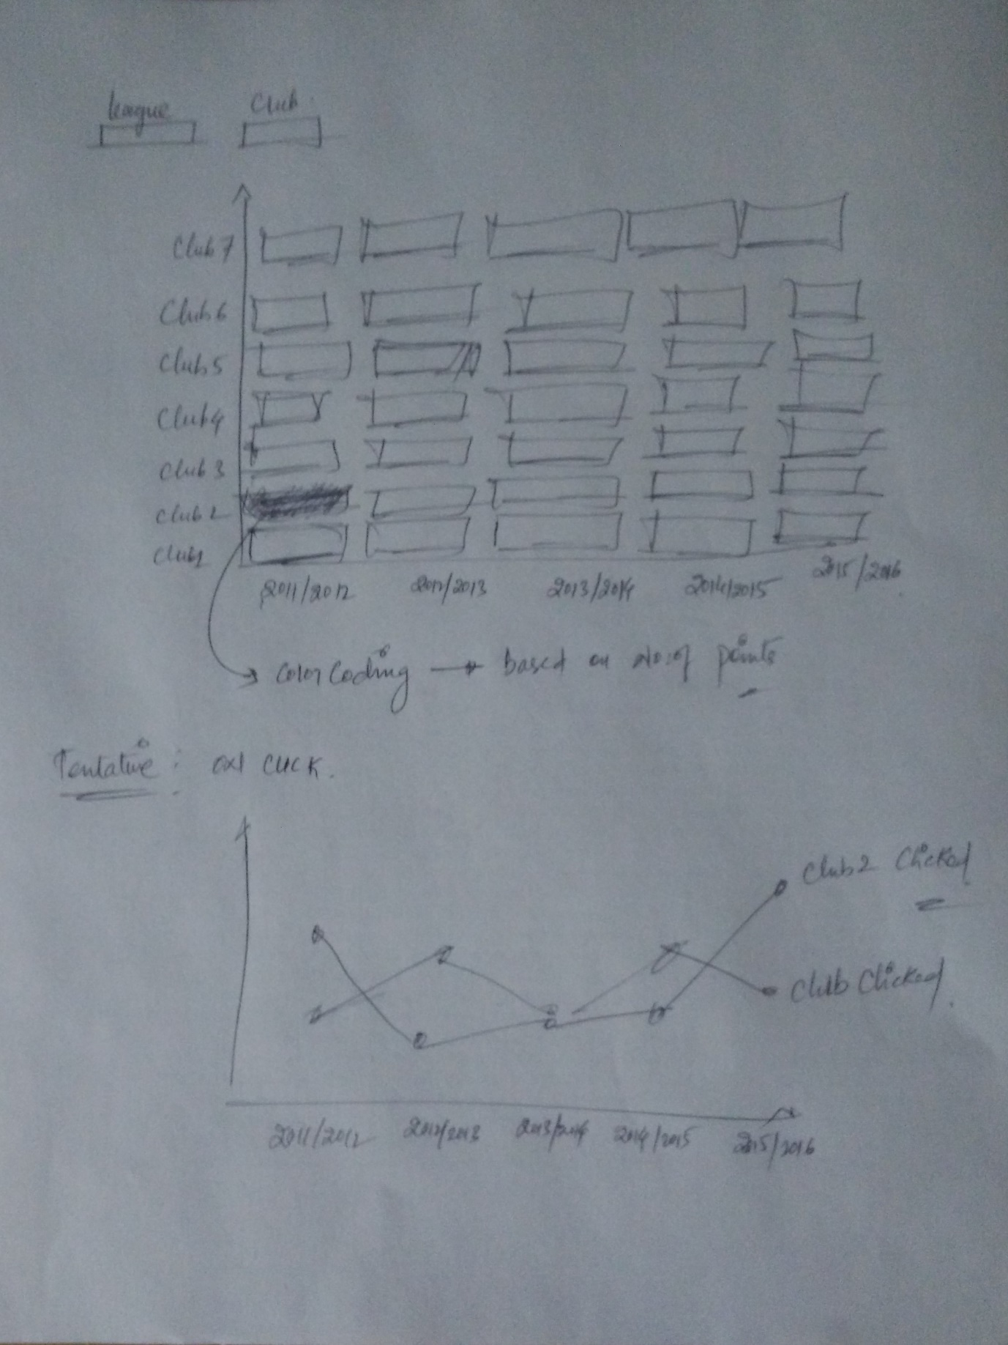

**Initial Design pics to start with :**

